**Deciding on a web framework**

Django

Django is a popular open source Python framework. It has much more online support than Blazor, as it is more widely used and has been around for much longer than Blazor.  
It provides relatively easy database management and is highly scalable and secure. Django protects against SQL injection which is important if we choose to make use of a database as well as Azure table storage. Django provides a robust project structure which we believe will be beneficial as it provides less room for error or subjectivity.

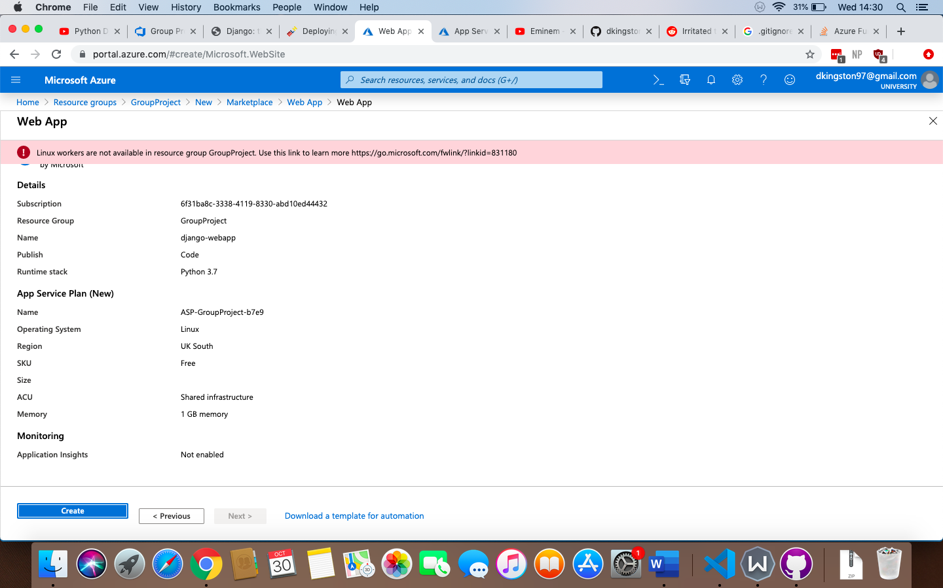When attempting to create the web app service and add it to our resource group, the following error occurs:

<https://docs.microsoft.com/en-gb/azure/app-service/containers/app-service-linux-intro#limitations>

The above link states the following:

“App Service on Linux is only supported with [Free, Basic, Standard, and Premium](https://azure.microsoft.com/pricing/details/app-service/plans/) app service plans and does not have a [Shared](https://azure.microsoft.com/pricing/details/app-service/plans/) tier. You cannot create a Linux Web App in an App Service plan already hosting non-Linux Web Apps.”

Dexter and I discussed this, and to get around this limitation of Azure, Dexter moved the App Service Plan for the API to a Linux platform, so that we would not have to deal with any non-Linux Web Apps, which allows us to keep everything on a single resource group. However, after deploying the Django app to the app service we encountered another error when a user navigates to the website. The deployment process for Django was time consuming, and we decided to look at an alternative so that the group could begin working on their projects without further delays.

Angular

We have decided to use Angular as the front-end framework. Angular is an open source TypeScript-based framework developed by Google. Most of the members of the group have at least some experience with JavaScript.

Deployment to Azure is far simpler than Django, and there is a lot of online support available due to the popularity of the framework.